Quantitative Finance for Cryptocurrency

April-2018

White Paper

Analytics and Insights

**Rohit Garg**

Delivery Manger

garg.rohit2@tcs.com

|  |
| --- |
| **Confidentiality Statement** |
| The information contained in this document is confidential and proprietary to TATA Consultancy Services. This information may not be disclosed, duplicated or used for any other purposes. The information contained in this document may not be released in whole or in part outside TCS for any purpose without the express written permission of TATA Consultancy Services |

|  |
| --- |
| **Tata Code of Conduct** |
| We, in our dealings, are self-regulated by a Code of Conduct as enshrined in the Tata Code of Conduct. We request your support in helping us adhere to the Code in letter and spirit. We request that any violation or potential violation of the Code by any person be promptly brought to the notice of the Local Ethics Counselor or the Principal Ethics Counselor or the CEO of TCS. All communication received in this regard will be treated and kept as confidential. |



**Table of Content**

Abstract 4

1. CCAR Secured Model Development 5

1.1 Intended Use of the Model 5

1.2 Model Assumption and Framework 5

1.3 State Transition Model 6

1.4 Model Performance 7

2. Variable Transformations 8

2.1 Methodology 8

2.2 Types of Nonlinear Transformations 9

2.2.1 Atan Transformation 9

2.2.2 Linear Spline Transformation 10

2.2.3 Quadratic Transformation 10

2.2.4 Inverse Quadratic Transformation 10

2.2.5 Logit Transformation 11

2.2.6 Generalized Logit Transformation 11

2.3 Results 11

3. Using Solver for Nonlinear Transformations 13

3.1 Variable (CLTV) 13

3.2 Transformation (Atan) 14

3.2.1 Initial value of the Parameters 15

3.2.2 Final value of the Parameters 15

4. Conclusion 16

4.1 Final Variable Equation 16

5. Appendix: Setting up the Solver 17

**Table of Tables**

Table 1: Loan State Transition Matrix 6

Table 2: Advantages and Limitations of State Transition Models 6

Table 3: Model Performance 7

Table 4: List of Candidate Functional Transformations 9

Table 5: Parameters and Errors 12

Table 6: Y axis - denotes binned coefficients of the variable 13

Table 7: X axis - denotes the median value of the variable CLTV 14

**Table of Figures**

Figure 1: Nonlinear Transformation 8

Figure 2: Atan Transformation 9

Figure 3: Linear Spline Transformation 10

Figure 4: Quadratic Transformation 10

Figure 5: Inverse Quadratic Transformation 10

Figure 6: Logit Transformation 11

Figure 7: Generalized Logit Transformation 11

Figure 8: Current Loan to Value 13

Figure 9: Atan Transformation 14

Figure 10: Initial value of the Parameters 15

Figure 11: Final value of the Parameters 15

Figure 12: Setting up the Solver 17

**Table of Equations**

Equation 1: Atan Function 14

Equation 2: Final Variable Equation 16

# Abstract

**Advance Nonlinear Variable Transformations – CCAR (2017) Secured Model Development**

Logistic regression assumes linearity of independent variables and log odds. Whilst it does not require the dependent and independent variables to be related linearly, it requires that the independent variables are linearly related to the log odds. Otherwise the test underestimated the strength of the relationship and rejects the relationship easily where it should be significant.

Sometimes relationships between Y (log odds) and one or more of the Xi’s is nonlinear. The nonlinear models can be made linear by appropriate transformations. In this paper, advance nonlinear variable transformations have been discussed such as:

1. Atan
2. Linear Spline
3. Quadratic
4. Inverse Quadratic
5. Logit
6. Generalized Logit

Transformations are applied to the original model prior to preforming regression. This is often sufficient to make the regression model appropriate for the transformed data. During model estimation continuous variables are binned. If the coefficient pattern suggests that the underlying variable is nonlinear various transformations are applied on the binned variable. A set of initial values was selected for each of the parameters and Solver[1] (Excel Add-in) is used to get the final values of the parameters such that the MAPE is minimum. The transformation is selected based on the shape and lower MAPE among the various options available.

**Note:** The data represented in this paper is an approximation to the original data.

# CCAR Secured Model Development

The primary objective of CCAR secured model was to stress test the business unit’s mortgage balances using a set of scenarios provided by the Federal Reserve Bank (FRB) as well as Bank Holding Company’s (BHC) own base and stress scenarios in the context of the CCAR exercise. Therefore, a critical step in the model development is to identify statistically significant relationships between loan performance and a set of macroeconomic variables. Establishing these relationships allows the model development team to construct a method for producing projections of mortgage performance under periods of market stress.

## Intended Use of the Model

This model is used to estimate PD (180+ DPD – units at account level) and GCL (180+ DPD – balances at account level) for mortgage portfolio through transition matrix methodology. The model forecasts credit losses in support of capital planning and regulatory mandated stress testing. The model is used to forecast losses for all CCAR macroeconomic scenarios (eg – BHC[2] baseline, BHC downside, FRB[3] baseline, FRB adverse, FRB severely adverse).

## Model Assumption and Framework

The model is in the loan level, roll rate framework producing unit and balance incidence at default. The implicit assumption of the model is that patterns, conditional on observables like loan characteristics and macroeconomic variables, in delinquency and terminal state transitions will persist for any extended period of time.

The loan mortgage is a probabilistic loan state transition matrix model. The model development team utilized a parametric multinomial logistic regression to construct a multi-dimensioned loan state transition matrix model. The model approach is grounded in portfolio specific historical residential loan data. This included mortgage pre-payment, delinquency and liquidation behaviour for the mortgage loan portfolio.

There are certain assumptions made within the model development. These assumptions are technical in nature and are appropriate to the model’s operation, but may or may not be tested for model performance.

* Transition model are based on historical customer behaviours to predict future relationship between model drivers and the transition probability. Customer behaviour might change in future where the model might not work and need re-calibration.
* Due to low volume in certain transitions, probability assumptions were made based on empirical analysis. Ideally, high delinquency buckets (i.e. 90-120, 90-150, 90-180, 120-150, etc) should be modelled but due to low volume it is not feasible.
* The model assumes that if a loan hits its first default (108 DPD, PCO[4], FCO[5]), it will not be allowed to go back to delinquency buckets. This default state is considered as final state in transition.
* The transitions grouped into same block have the same sensitivity towards model predictors.

## State Transition Model

State transition modelling is another commonly used industry practice for forecasting losses. Unlike survival models state transition models are developed to predict intermediate transitions (Current, 30 DPD, etc) as well as the terminal state (default and payoff). State transition models can be built using loan level panel data and achieve the granularity required for handling changes in customer, product an economic drivers. Survival models are, in fact, a variant of state transition model. Specifically, it can be shown that if intermediate transitions are removed and estimate the model using logistic regression will lead to survival model.

Table 1: Loan State Transition Matrix

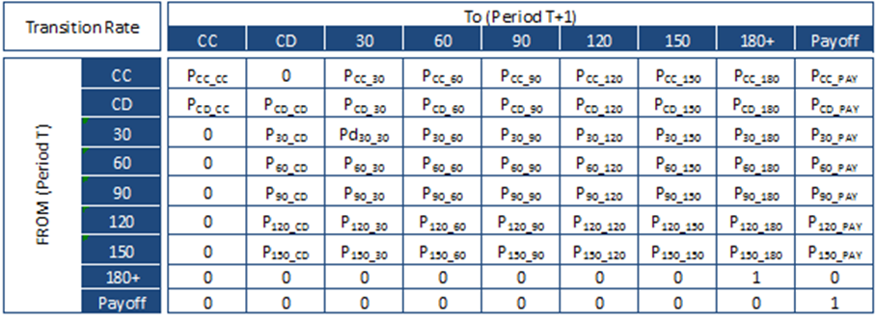

Two widely used approaches to build a state transition model are[6]:

* Markov process (prediction in period t only depends on the state in period t-1)
* Monte Carlo simulation (relaxes the assumption that prediction in period t is only dependent on the state in period t-1)

**State transition modelling approach was selected as it meets the functional requirement to model the intermediate states. Additionally, Markov process was selected rather than Monte Carlo simulation due to computational complexity.**

Table 2: Advantages and Limitations of State Transition Models

|  |  |
| --- | --- |
| **Advantages** | **Limitations** |
| * Flexible approach that allows for a more structural view of how a loan behaves across the account life cycle * Predicts intermediate outcomes * Captures customers, product and economic risk drivers | * More models to estimate * Model is more complex to implement and maintain * Computationally more complex than either roll rate or survival models |

## Model Performance

Various statistics like Gini coefficient, ROC, Mean Absolute Percentage Error (MAPE) and Bias were evaluated to test for the model accuracy and discriminative power.

Table 3: Model Performance

|  |  |  |
| --- | --- | --- |
| **Model Performance** | **Tests** | **Comments** |
| **Predictive accuracy of the model** | MAPE and Bias | Lower MAPE and Bias indicate better model fit. For the current project the tolerance level as specified as:   * MAPE should be less than 25%. * Bias should be between -5% to +5% |
| **Discriminatory power of the model** | Gini and ROC | As a rule of thumb, large Gini, better the model fit. ROC measurement is better if it is closer to 1 than to 0.5 |
| **Model robustness and stability** |  | To test model robustness and stability, coefficient comparison has been done between original model estimation and re-estimation without last 18-months for the training data. This test has been performed individually across all the modelled transition states. |

# Variable Transformations

Transforming a variable involves using a mathematical operation to change its measureable scale. There are two kinds of transformations:

* **Linear Transformation:** Preserves linear relationship between variables. Therefore, correlation between x and y would be unchanged after a linear transformation.
* **Nonlinear Transformation:** Changes linear relationship between variables, and thus, changes the correlation between variables.

Figure 1: Nonlinear Transformation

## Methodology

During model estimation continuous variables are binned. If the coefficient pattern suggests that the underlying variable is nonlinear, a range of mathematical functions designed to transform the variable are explored to have linear relationship with the target outcome. The transformation are chosen to reasonably fit the observed data and have desirable theoretical properties outside the range of observed data. The process for selecting the appropriate transformation is discussed below:

**Step 1:** Bin the continuous variable and estimate a regression model using the binned data. Binning should be reasonably granular (typically 10+ bins). Additional bins may be created if the upper or lower bins obscure the range of interest.

**Step 2:** Evaluate the shape of the parameter estimates and select a shape that best captures the general trend and has theoretically defensible properties. Binned model parameters are plotted on the Y-axis while the mean or median value of the predicted variable is plotted on the X-axis.

**Step 3:** Manually select the initial set of transformation function parameters so as to reasonably approximate the observed pattern in the coefficients. Manual selection is generally required for the initial starting point as the number of unique parameters is small. Fit metrics like average error (bias) and MAPE (precision) are calculated.

**Step 4:** Using the starting values calculated in step 3, re-estimate the parameters using nonlinear estimation procedure. The model developer evaluates the results for model fit and theoretical properties outside the range of observed data.

**Step 5:** Model developer alternates between step 3 (judgemental adjustments to parameters) and step 4 (statistical optimization) until a satisfactory solution is obtained.

## Types of Nonlinear Transformations

Table 4: List of Candidate Functional Transformations

|  |  |  |
| --- | --- | --- |
| **Transformation** | **Formula Used** | **Note** |
| **Atan** | Y = a + b * ATAN (c * (X – d)) | Where, Y is the effect  X is the variable mean or median  a, b, c and d are parameters |
| **Linear**  **Spline** | Y = a (if x <= k)  Y = a + b * (X – k) (otherwise) | Where, Y is the effect  X is the variable mean or median  a, b and k are parameters |
| **Quadratic** | Y = a + b * X + c * X ^ 2 | Where, Y is the effect  X is the variable mean or median  a, b and c are parameters |
| **Inverse**  **Quadratic** | Y = a + b / (X – d) + d /(X – d)^2 | Where, Y is the effect  X is the variable mean or median  a, b, c and d are parameters |
| **Logit** | Y = a + L / (a + exp (-k * (x – x0))) | Where, Y is the effect  X is the variable mean or median  a, k, L and x0 are parameters |
| **Generalized**  **Logit** | Y = a + (k – a) /  (c + q * exp (-b * (x- m)) ^ (1/v)) | Where, Y is the effect  X is the variable mean or median  a, b, c, k, m, q and v are parameters |

### Atan Transformation

Figure 2: Atan Transformation

|  |  |
| --- | --- |
|  | * Parameter “a” shifts the transformation line up or down * Parameter “d” shifts the transformation line left or right * Parameter “b” defines the height of the curve and the direction of the curve * Parameter “c” defines the slope of the curve and the direction of the curve |

### Linear Spline Transformation

Figure 3: Linear Spline Transformation

|  |  |
| --- | --- |
|  | * Parameter “a” shifts the transformation line up or down * Parameter “k” defines the point where the original series shows a shift in slope * Parameter “b” defines the slope of the curve and the direction of the curve |

### Quadratic Transformation

Figure 4: Quadratic Transformation

|  |  |
| --- | --- |
|  | * Parameter “a” shifts the transformation line up or down * Parameter “d” shifts the transformation line left or right * Parameter “b” defines the slope of the curve and the direction of the curve * Parameter “c” defines the direction of the curve |

### Inverse Quadratic Transformation

Figure 5: Inverse Quadratic Transformation

|  |  |
| --- | --- |
|  | * Parameter “a” shifts the transformation line up or down * Parameter “d” shifts the transformation line left or right * Parameter “b” and “c” defines the direction of the curve |

### Logit Transformation

Figure 6: Logit Transformation

|  |  |
| --- | --- |
|  | * Parameter “a” shifts the transformation line up or down * Parameter “xo” shifts the transformation line left or right * Parameter “L” defines the height of the curve and the direction of the curve * Parameter “k” defines the slope of the curve and the direction of the curve |

### Generalized Logit Transformation

Figure 7: Generalized Logit Transformation

|  |  |
| --- | --- |
|  | * Parameter “a” shifts the transformation line up or down * Parameter “m” shifts the transformation line left or right * Parameter “m” defines the height of the curve and the direction of the curve * Parameter “b”, “c”, “k” and “q” defines the slope of the curve and the direction of the curve |

## Results

Various transformations (Atan, Linear Spline, Quadratic, Inverse Quadratic, Logit and Generalized Logit) were applied on the binned variable (CLTV[7]). A set of initial values was selected for each of the parameters and Solver (Excel Add-in) was used to get the final values of the parameters such that the MAPE[8] is minimum. The transformation was selected based on the shape and lower MAPE among the various options available. The following table summarizes the initial values of the parameters, final values of the parameters, and Error (Bias and MAPE).

Table 5: Parameters and Errors

|  |  |  |  |
| --- | --- | --- | --- |
| **Transformation** | **Initial value of the**  **Parameters** | **Final value of the**  **Parameters** | **Error** |
| **Atan** | A = -1.40 (approx. midpoint)  D = 90 (approx. midpoint)  B = (1.6-1.2)/Pi = 0.12734  (height of curve / pi)  C = - 0.0044 (slope) | A = -1.3985  B = 0.1680  C = -0.0746  D = 91.0337 | Bias = -0.04%  MAPE = 0.90% |
| **Linear**  **Spline** | A = -1.20 (top of the curve)  B = - 0.0044 (slope)  K = 90  (point where the slope changes) | A = -1.1159  B = -0.0052  K = 54.3460 | Bias = -0.90%  MAPE = 1.42% |
| **Quadratic** | A = -1.20 (top of the curve)  B = - 0.0044 (slope)  C = 0  (ratio of y / x^2)  D = 90 (approx. midpoint) | A = -1.1968  B = - 0.0045  C = -0.0001  D = 71.7422 | Bias = -0.29%  MAPE = 0.92% |
| **Inverse**  **Quadratic** | A = -1.20 (top of the curve)  B = 200 (ratio of x / y *2)  C = 100 (ratio of x / y)  D = 130 (right most point) | A = -0.3124  B = 187.1846  C = 100.6881  D = 280.2597 | Bias = -1.11%  MAPE = 2.68% |
| **Logit** | A = -1.40 (approx. midpoint)  Xo = 90 (approx. midpoint)  L = 1.6-1.2 = 0.4  (height of curve)  K = - 0.0044 (slope) | A = -1.5418  Xo = 91.8547  L = 0.4244  K = -0.0865 | Bias = -0.29%  MAPE = 0.92% |
| **Generalized**  **Logit** | A = K = -1.20 (top of the curve)  V = 1.6-1.2 = 0.4  B= 0.013 (Pi * slope * -1)  (height of curve)  M = 90 (approx. midpoint)  C = Q = - 0.0044 (slope) | A = -1.1163  K = -1.1188  V = 0.5010  B = 0.0380  M = 96.4385  C = 0.0058  Q = 0.0044 | Bias = -0.37%  MAPE = 1.05% |

**ATAN is selected as the final transformation:**

* **MAPE is the lowest (MAPE = 0.90%)**
* **Shape is intuitive (S-Shaped)**

# Using Solver for Nonlinear Transformations

Excel includes a tool called “solver” that uses techniques from the operations research to find the optimal solutions for all kinds of decision problems. The “solver” is on the “data” tab. To formulate the linear programming model for “solver” to solve, the three questions must be addressed:

1. What are the decisions to be made?
2. What are the constraints on these decisions?
3. What is the overall measure of performance of these decisions?

## Variable (CLTV)

Current Loan to Value (CLTV) is a risk assessment ratio that financial institutions use. It is defined as the ratio of current outstand balance (mortgage amount) to value of the collateral (property). Typically, assessments with high CLTV ratios are generally seen as higher risk.

Figure 8: Current Loan to Value

|  |  |
| --- | --- |
|  | * The graph represents the trend of CLTV for improvement models[9]. As the CLTV increases the improvement rate decreases. * Y axis denotes binned coefficients of the variable (Log Odds Scale) * X axis denotes the median value of the variable CLTV |

Table 6: Y axis - denotes binned coefficients of the variable

|  |  |  |  |  |  |  |
| --- | --- | --- | --- | --- | --- | --- |
| **Parameter** | **Bucket** | **DF** | **Estimate**  **(Y axis)** | **Standard**  **Error** | **Wald Chi**  **Square** | **Pr >**  **ChiSq** |
| Curr_LTV_ | 0 | 1 | **0.4074** | 0.0408 | 99.6258 | <0.0001 |
| Curr_LTV_ | 1 | 1 | **0.4100** | 0.0392 | 109.6540 | <0.0001 |
| Curr_LTV_ | 2 | 1 | **0.3603** | 0.0381 | 89.3603 | <0.0001 |
| Curr_LTV_ | 3 | 1 | **0.3439** | 0.0389 | 78.2623 | <0.0001 |
| Curr_LTV_ | 4 | 1 | **0.2656** | 0.0378 | 49.2689 | <0.0001 |
| Curr_LTV_ | 5 | 1 | **0.2575** | 0.0389 | 43.9183 | <0.0001 |
| Curr_LTV_ | 6 | 1 | **0.2171** | 0.0384 | 31.9196 | <0.0001 |
| Curr_LTV_ | 7 | 1 | **0.0977** | 0.0383 | 26.5174 | <0.0001 |
| Curr_LTV_ | 8 | 1 | **0.0562** | 0.0389 | 12.0888 | <0.0001 |
| Curr_LTV_ | 9 | 0 | **0** | 0 | . | . |

Table 7: X axis - denotes the median value of the variable CLTV

|  |  |  |  |  |  |  |
| --- | --- | --- | --- | --- | --- | --- |
| **Curr_LTV_** | **Count** | **Event**  **Count** | **Event**  **Rate** | **Min** | **Max** | **Median**  **(X axis)** |
| 0 | 8,543 | 3,039 | 35.57% | 0 | 39 | **23** |
| 1 | 8,198 | 2,789 | 34.02% | 40 | 57 | **50** |
| 2 | 9,031 | 2,916 | 32.29% | 58 | 68 | **64** |
| 3 | 7,858 | 2,478 | 31.53% | 69 | 75 | **72** |
| 4 | 9,068 | 2,689 | 29.65% | 76 | 82 | **79** |
| 5 | 7,861 | 2,260 | 28.75% | 83 | 88 | **85** |
| 6 | 8,365 | 2,237 | 26.74% | 89 | 95 | **92** |
| 7 | 9,014 | 2,112 | 23.43% | 96 | 104 | **100** |
| 8 | 8,668 | 1,848 | 21.32% | 105 | 118 | **110** |
| 9 | 8,312 | 1,598 | 19.23% | 119 | 509 | **134** |

## Transformation (Atan)

ARCTAN (Atan) returns the inverse tangent (Tan-1) of the element X. The Atan function operates element wise arrays. For real elements of X, Atan (X) returns values in the interval [ -pi/2, pi/2 ]. For complex values of X, Atan (x) returns complex values. All angles are in radians. Inverse tangent is defined as:

Equation 1: Atan Function

|  |
| --- |
| **Tan-1 (X) = i / 2 * ln ((i+X) / (i-X))** |

Rules of Atan:

* X = -∞, Atan (rad) = -π/2
* X = 0, Atan (rad) = 0
* X = ∞, Atan (rad) = π/2

**The ARCTAN is a sigmoidal function with a general shape as shown below:**

Figure 9: Atan Transformation

|  |  |
| --- | --- |
|  | * The function was parameterized as follows:   Y = a + b * ATAN (c * (X – d))   * Assumption:   A = 0, B = 1, C = 1 and D = 0 |

### Initial value of the Parameters

Figure 10: Initial value of the Parameters

|  |  |
| --- | --- |
|  | * A = -1.40 (approx. midpoint) * B = (1.6-1.2)/Pi = 0.12734 (height of curve / pi) * C = - 0.0044 (slope) * D = 90 (approx. midpoint) * Bias = 4.57% * MAPE = 10.19% |

### Final value of the Parameters

Figure 11: Final value of the Parameters

|  |  |
| --- | --- |
|  | * A = -1.3985 * B = 0.1680 * C = -0.0746 * D = 91.0337 * Bias = -0.04% * MAPE = 0.90% |

# Conclusion

Logistic regression does not make any of the key assumptions of linear regression models that are based on ordinary least squares algorithm, particularity regarding linearity, normality, homoscedasticity, and measurement level. However, logistic regression assumes linearity of independent variables and log odds. Whilst it does not require the dependent and independent variables to be related linearly, it requires that the independent variables are linearly related to the log odds. Otherwise the test underestimated the strength of the relationship and rejects the relationship easily (i.e. being not significant – rejecting the null hypothesis) where it should be significant.

Although transformations can result in improvement of a specific modelling assumption, such as linear or homoscedasticity, they can often result in the violation of others. Thus, transformations must be used in an iterative fashion, with continued checking of other modelling assumptions as transformations are made. It is possible that an improvement in one model assumption brought about by a transformation may result in a more serious violation of another assumption requisite of the model.

Rules with transformations:

1. Transformation on a dependent variable will change the distribution of error term in a model.
2. Nonlinearities between the dependent variable and an independent variable often can be linearized by transforming the independent variable.
3. Models should only be compared on the original units of the dependent variable and not the transformed units.

## Final Variable Equation

Y = a + b * ATAN (c * (X – d))

Where:

Y is the transformed CLTV

X is the original CLTV

A = -1.3985, B = 0.1680, C = -0.0746, D = 91.0337

Equation 2: Final Variable Equation

|  |
| --- |
| **CLTV_transformed = -1.3985 + 0.1680 * ATAN (-0.0746 * (CLTV - 91.0337))** |

# Appendix: Setting up the Solver

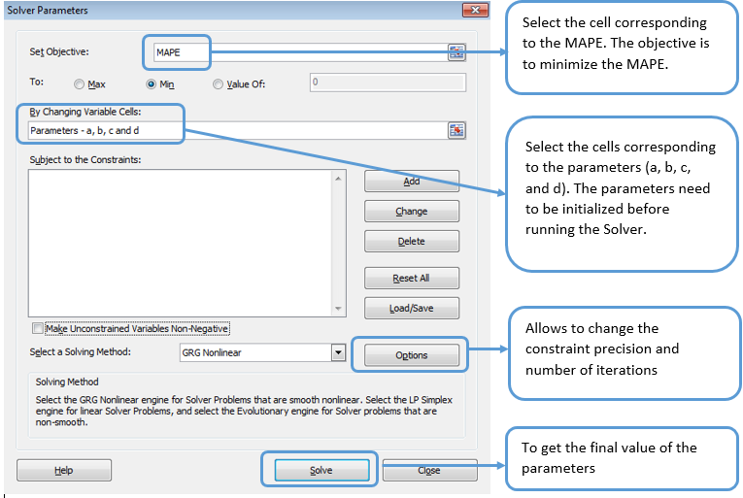

Figure 12: Setting up the Solver

**Cross Hedging of Cryptocurrency**

Rohit Garg ([f2005636@gmail.com](mailto:f2005636@gmail.com))

**Cryptocurrency**

A cryptocurrency a digital asset designed to work as a medium of exchange that uses cryptography to secure its transactions. Cryptocurrencies are classified as a subset of digital currencies and are also classified as a subset of alternative currencies and virtual currencies.

**Figure 1: How Cryptocurrency works**

**The economics behind cryptocurrency:** Cryptocurrency is essentially a fiat currency. This means users must reach a consensus about cryptocurrency's value and use it as an exchange medium. However, because it is not tied to a particular country, its value is not controlled by a central bank. With bitcoin, the leading functioning example of cryptocurrency, value is determined by market supply and demand, meaning that it behaves much like precious metals, like silver and gold. Cryptocurrency is designed to bring back a "decentralized currency of the people", taking centralized banks out of the equation. Because bitcoins must be cryptographically signed each time they are transferred, each bitcoin user has both public and individual private keys.

**Possible abuse of crypto currencies:** Cryptocurrency transactions are anonymous, untraceable and have created a niche for illegal transactions, like drug trafficking. Because the currency has no central repository, law enforcement and payment processors have no jurisdiction over bitcoin accounts. For cryptocurrency supporters, this anonymity is a primary strength of this technology, despite the potential for illegal abuse, as it enables a shift in power from institutions to individuals.

**Types of Cryptocurrencies:** Although there are technically over 1000 cryptocurrencies, only few are discussed below:

**Figure 2: Types of Cryptocurrencies**

|  |  |
| --- | --- |
| Prevailing bitcoin logo | **Bitcoin (BTC)**: Bitcoin is the first decentralized digital currency, as the system works without a central bank or single administrator. It has the highest market cap, its coins generally trade at the highest cost of all cryptocurrencies. Bitcoins are created as a reward for a process known as mining. |
| C:\Users\rg83892\Desktop\download.png | **Ethereum (ETH):** Ether is a cryptocurrency whose blockchain is generated by the Ethereum platform. Ether can be transferred between accounts and used to compensate participant mining nodes for computations performed. It doesn’t have the longevity at the top like Litecoin, but it is built on a system that other coins are built on. Most ICOs (Initial Coin Offerings) use ethereum. |
| Ripple logo.svg | **Ripple (XRP):** Ripple was released in 2012, Ripple purports to enable secure, instantly and nearly free global financial transactions of any size with no chargebacks. Ripple tends to have a steady price due to its large supply. It has had staying power over time. |
| 6 Full Logo S-2.png | **Litecoin (LTC):** Litecoin is a peer-to-peer cryptocurrency and open source software project released under the MIT/X11 license. The Litecoin Network aims to process a block every 2.5 minutes, rather than Bitcoin's 10 minutes. The developers claim that this allows Litecoin to have faster transaction confirmation. |
| Monero-Logo.svg | **Monero (XMR):** Monero is an open-source cryptocurrency created in April 2014 that focuses on privacy and decentralization that runs on Windows, macOS, Linux, Android, and FreeBSD. Monero uses a public ledger to record transactions while new units are created through a process called mining. |
| https://upload.wikimedia.org/wikipedia/en/thumb/a/a6/Dash_%28cryptocurrency%29_logo.svg/220px-Dash_%28cryptocurrency%29_logo.svg.png | **DASH (DASH):** Dash is an open source peer-to-peer cryptocurrency. On top of Bitcoin's feature set, it currently offers instant transactions, private transactions and operates a self-governing and self-funding model that enables the Dash network to pay individuals and businesses to perform work that adds value to the network. |
| NEM (cryptocurrency) logo.svg | **NEM (XEM):** NEM was launched on March 31, 2015. NEM has a stated goal of a wide distribution model and has introduced new features to blockchain technology such as its proof-of-importance (POI) algorithm, multisignature accounts, encrypted messaging, and an Eigentrust++ reputation system. |

**Data Summary**

Time series analysis is concerned with the analysis of data collected over time. Adjacent observations are typically dependent. Time series analysis hence deals with techniques for the analysis of this dependence.

**We create a zoo objects called btc from the daily closing prices of Bitcoin and ltc from the daily closing prices of Litecoin which are stored in the CSV files.** Each line on the sheet contains a date and a closing price separated by a comma. The first line contains the column headings (Date and Close). To get a first impression of the data, we plot the price chart:

**Figure 3: Closing prices of Bitcoin (BTC) and Litecoin (LTC)**

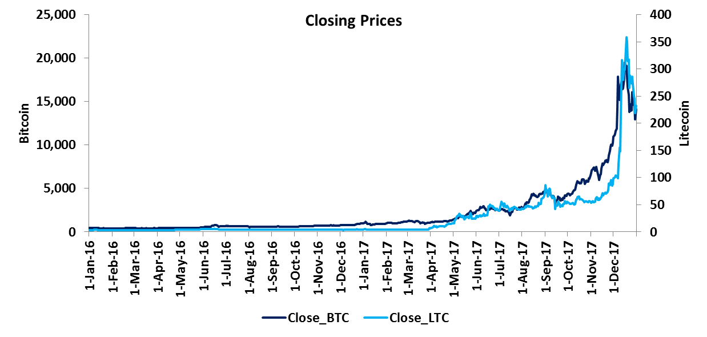

**Table 1: Date Range and Data Range**



When dealing with time series, one is normally more interested in returns instead of prices. This is because returns are usually stationary. So we will calculate continuously compounded returns:

**ret_btc = diff(log(btc)) * 100**

**ret_ltc = diff(log(ltc)) * 100**

**Cross Hedging Bitcoin**

Since the price of Bitcoin can be volatile, most investors should hedge at least part of their exposure to Bitcoin price changes. In the absence of Bitcoin OTC instruments, investors can use related cryptocurrencies for hedging purposes. In this example Litecoin has been used to hedge.

**Cointegration: The idea behind cointegration is to find a linear combination between non-stationary time series that result in a stationary time series. It is hence possible to detect stable long-run relationships between non-stationary time series.**

Testing Bitcoin for stationarity: The null hypothesis of non-stationarity (Bitcoin time series contains a unit root) cannot be rejected at the 1% significance level

**Table 2: Testing Bitcoin for stationarity**



Testing Litecoin for stationarity: The null hypothesis of non-stationarity (Litecoin time series contains a unit root) cannot be rejected at the 1% significance level

**Table 3: Testing Litecoin for stationarity**



**Now we try to estimate the hedge ratio by using an existing long-run relationship between the levels of Bitcoin and Litecoin prices. We obtain a hedge ratio of 61.23.**

**Table 4: Estimating hedge ratio**



Testing error for stationarity: The null hypothesis of non-stationarity is rejected at the 1% significance level

**Table 5: Testing error for stationarity**



**Thank You**

**Contact**

For more information, contact [**gsl.cdsfiodg@tcs.com**](mailto:gsl.cdsfiodg@tcs.com)(Email Id of ISU)

**About Tata Consultancy Services (TCS)**

Tata Consultancy Services is an IT services, consulting and business solutions organization that delivers real results to global business, ensuring a level of certainty no other firm can match. TCS offers a consulting-led, integrated portfolio of IT and IT-enabled infrastructure, engineering and assurance services. This is delivered through its unique Global Network Delivery ModelTM, recognized as the benchmark of excellence in software development. A part of the Tata Group, India’s largest industrial conglomerate, TCS has a global footprint and is listed on the National Stock Exchange and Bombay Stock Exchange in India.

For more information, visit us at **www.tcs.com**.

**IT Services**

**Business Solutions**

**Consulting**

All content / information present here is the exclusive property of Tata Consultancy Services Limited (TCS). The content / information contained here is correct at the time of publishing. No material from here may be copied, modified, reproduced, republished, uploaded, transmitted, posted or distributed in any form without prior written permission from TCS. Unauthorized use of the content / information appearing here may violate copyright, trademark and other applicable laws, and could result in criminal or civil penalties. **Copyright © 2011 Tata Consultancy Services Limited**

1. Excel includes a tool called Solver that uses techniques from the operations research to find the optimal solutions for all kinds of decision problems.
2. BHC – Bank Holding Company
3. FRB – Federal Reserve Bank
4. PCO – Partial Charge-Off
5. FCO – Full-Charge Off
6. The key difference between Markov process and Monte Carlo simulation, is that, Monte Carlo simulation a loan moves through time in discrete state (not as probabilistic events). Consequently we must use simulation to understand the likelihood of being in a given sate at any future point in time.
7. CLTV - Current Loan to Value
8. MAPE - Mean Absolute Percentage Error
9. Improvement is defined as the movement of an account from higher delinquency to lower delinquency (e.g. 60 DPD to 30 DPD)